1-

SELECT COUNT(*)
FROM flights_1

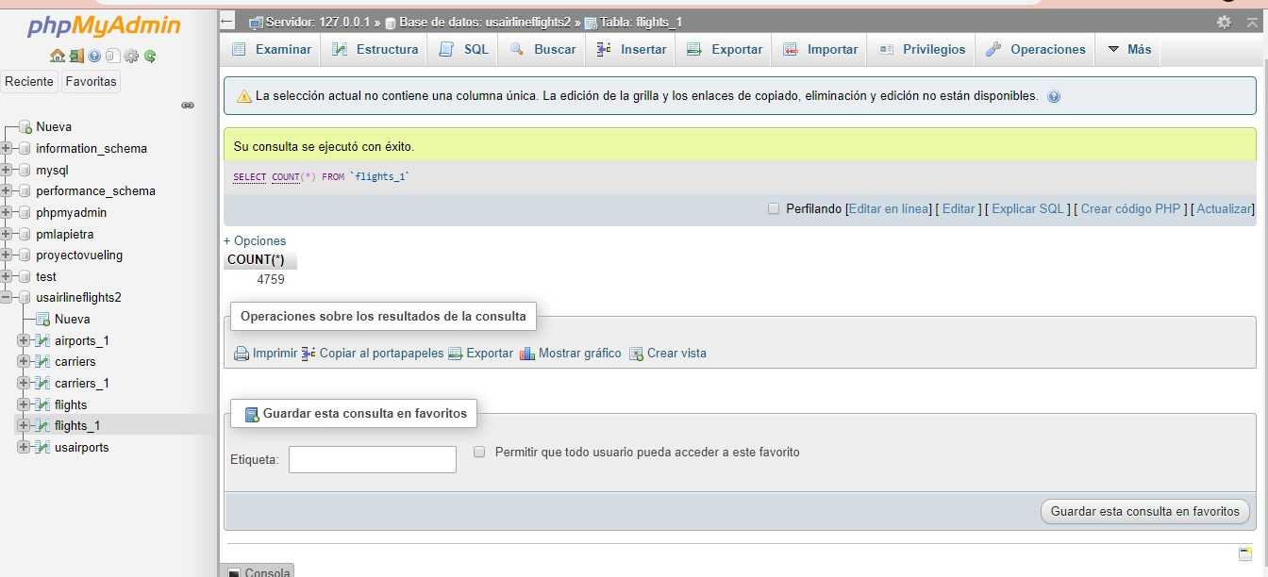

2
SELECT `COL 17`, AVG(`COL 15`), AVG(`COL 16`)
FROM flights_1
GROUP BY `COL 17`

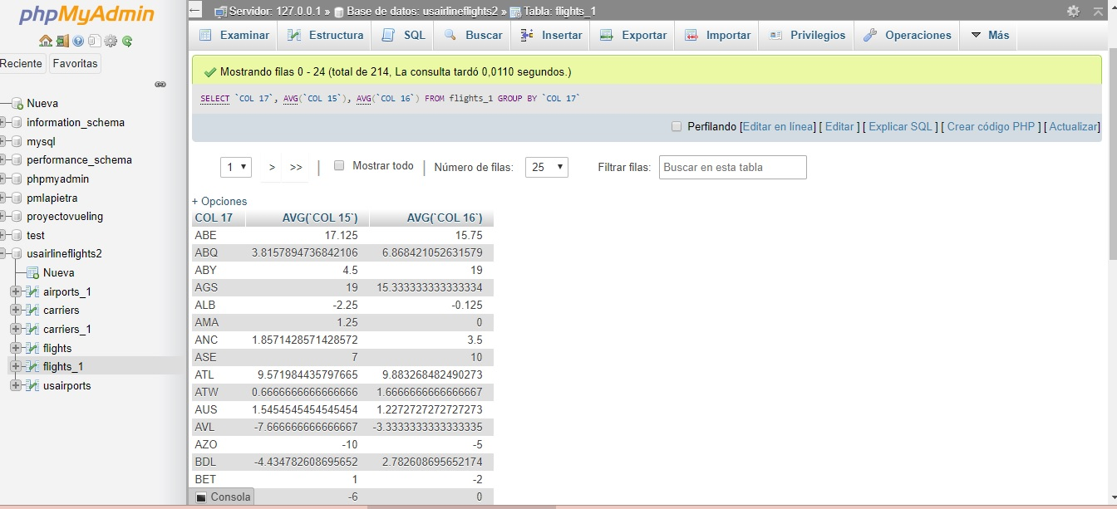

3
SELECT `COL 17` city, `COL 1` year, `COL 2` month, AVG(`COL 15`)
FROM `flights_1`
GROUP BY city, year, month

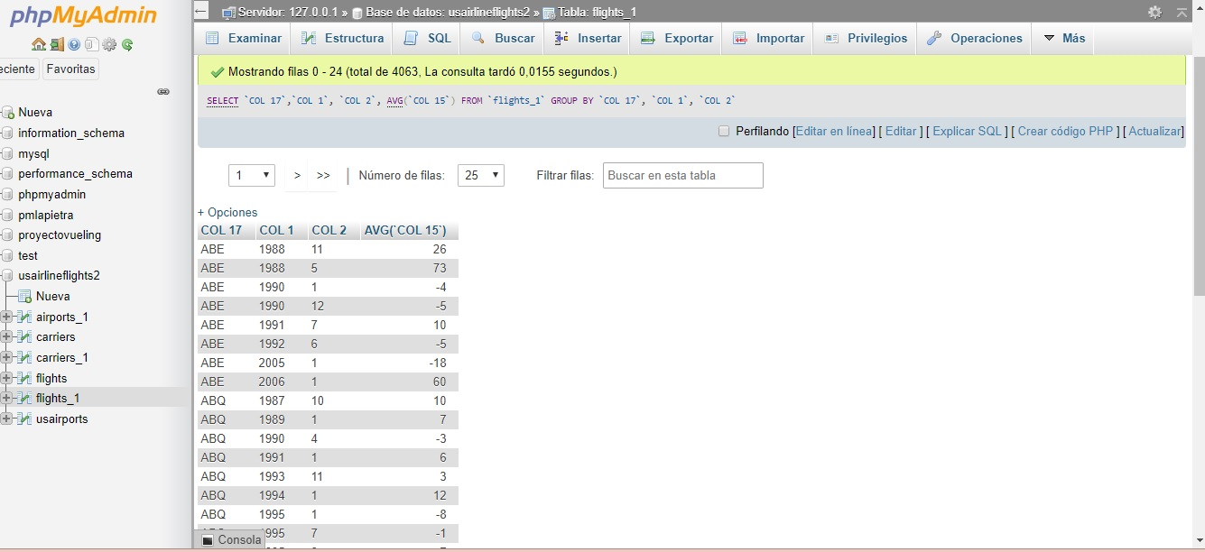

4
SELECT A.`COL 3` city, F.`COL 1` year, F.`COL 2` month, AVG(`COL 15`)
FROM `flights_1` F, `airports_1` A
WHERE F.`COL 17` = A.`COL 1`
GROUP BY city, year, month
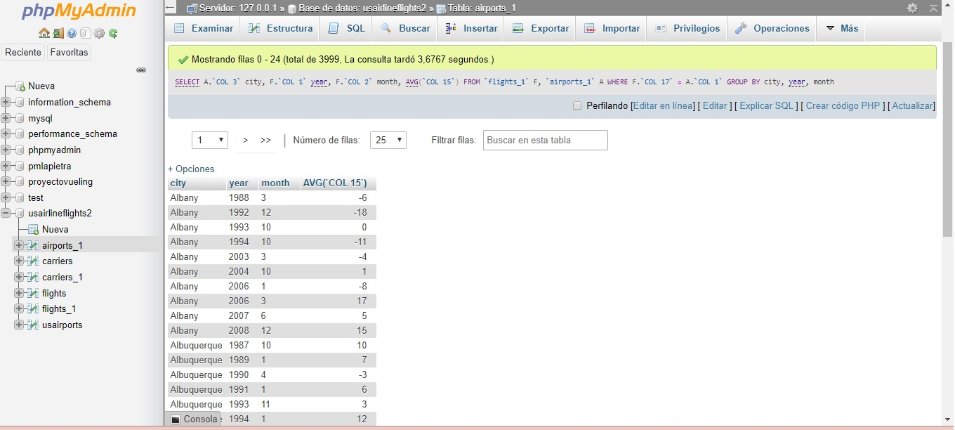

5
SELECT F.`COL 9` UC, F.`col 1` year, F.`col 2` month, F.`col 22` cancelations
FROM flights_1 F, carriers_1 C
WHERE C.`col 1` = F.`col 9`
ORDER BY cancelations DESC
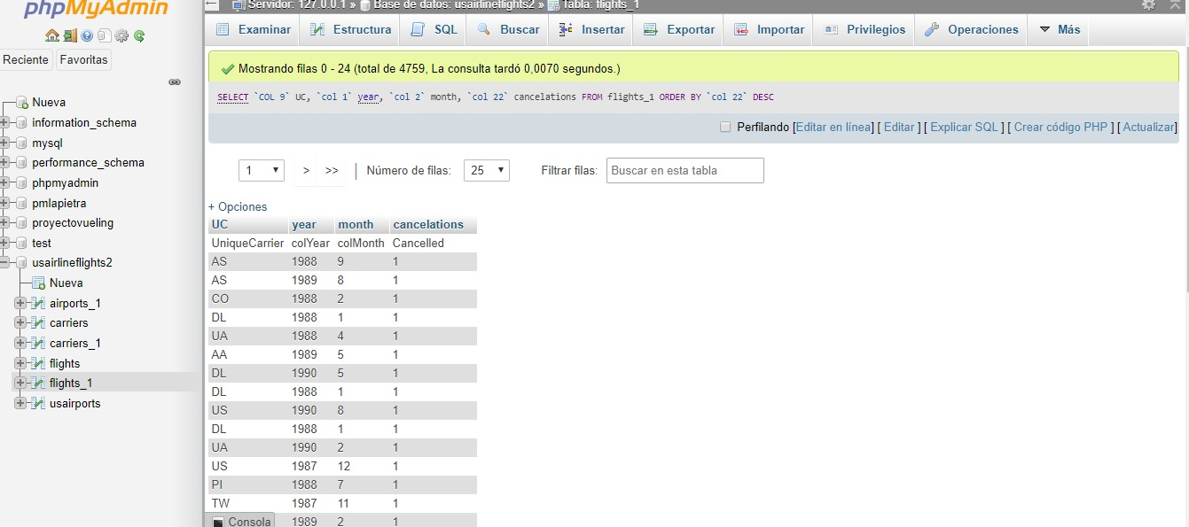

6
SELECT `COL 11` tailNumb, SUM(`COL 19`) totalDistance
FROM flights_1 F
WHERE `COL 11` IS NOT NULL
GROUP BY tailNumb
ORDER BY totalDistance DESC LIMIT 11

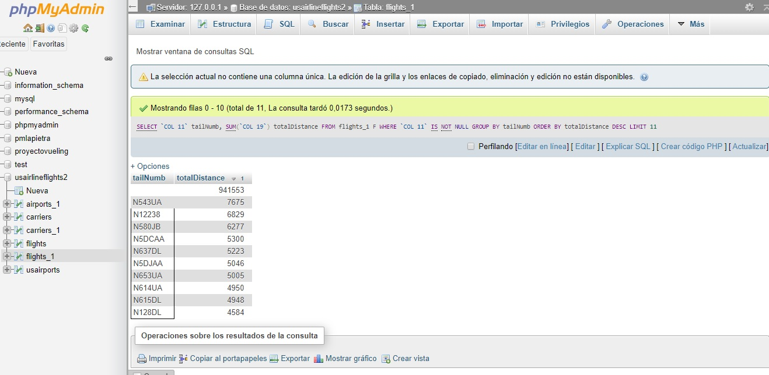

7

SELECT `COL 9` uniqueCarrier, AVG(`COL 15`) avgDelay
FROM flights_1 F
GROUP BY uniqueCarrier
HAVING avgDelay >10
ORDER BY avgDelay DESC

